Project Planning Phase
Project Planning Template (Product Backlog, Sprint Planning, Stories, Story points)

Date | 08 October 2026
Team ID | 9100RootAccess
Project Name | Auto Ticket Classification using ServiceNow Flow Designer
Maximum Marks | 5 Marks

Product Backlog, Sprint Schedule, and Estimation (4 Marks)
Use the below template to create product backlog and sprint schedule
Sprint | Functional Requirement (Epic) | User Story Number | User Story / Task | Story Points | Priority | Team Members
Sprint-1 | Requirement Analysis & Planning | USN-1 | As a team, we can define the business use case and the requirements for automatically classifying school IT helpdesk tickets. | 1 | High | Dakshayani R N R
Sprint-1 |  | USN-2 | As a developer, I can create a new update set (Project Update Set) and make it current so that all configuration changes are captured. | 1 | High | Harini Sri S
Sprint-1 |  | USN-3 | As a developer, I can follow the navigation steps in ServiceNow and document them through screenshots. | 1 | Low | Rubiga I
Sprint-1 | Backend Development & Configuration | USN-4 | As an IT admin, I can create a custom table (Incident WorkFlow) with auto-numbering to store ticket records. | 3 | High | Harini Sri S
Sprint-1 |  | USN-5 | As an IT admin, I can create the ticket fields (Caller, Category, Subcategory, Short Description, State, Assigned Group, Assigned to) with the correct data types and choices. | 2 | High | Dakshayani R N R
Sprint-1 |  | USN-6 | As an IT admin, I can make Subcategory dependent on Category so that only the matching subcategory choices are shown. | 2 | Medium | Rubiga I
Sprint-2 | Automation using Flow Designer & Email Notification | USN-7 | As a student or teacher, I can raise a ticket with only the Caller and Short Description, and the flow automatically fills the Category and Subcategory and emails me a confirmation. | 5 | High | Rubiga I
Sprint-2 | Testing, Validation & Security | USN-8 | As a tester, I can submit a Wi-Fi ticket and verify that Category = Network, Subcategory = Wi-Fi and the email is sent to the caller. | 1 | High | Dakshayani R N R
Sprint-2 |  | USN-9 | As a tester, I can submit a projector ticket and verify that Category = Hardware and Subcategory = Projector are filled by the flow. | 1 | Medium | Rubiga I
Sprint-2 |  | USN-10 | As a tester, I can submit password and slow-computer tickets and verify that they are classified as Access and Performance correctly. | 1 | Medium | Harini Sri S
Sprint-2 | Deployment & Documentation | USN-11 | As a developer, I can move the Project Update Set to Complete state and export it to XML for deployment. | 1 | High | Dakshayani R N R
Sprint-2 |  | USN-12 | As a team, we can complete the final documentation and conclusion of the project. | 1 | Low | Harini Sri S

Project Tracker, Velocity & Burndown Chart: (4 Marks)
Sprint | Total Story Points | Duration | Sprint Start Date | Sprint End Date (Planned) | Story Points Completed (as on Planned End Date) | Sprint Release Date (Actual)
Sprint-1 | 10 | 2 Days | 30 sep 2026 | 01 oct 2026 | 10 | 01 oct2026
Sprint-2 | 10 | 2 Days | 02 oct 2026 | 03 oct 2026 | 10 | 03 oct 2026

Velocity:
Imagine we have a 2-day sprint duration, and the velocity of the team is 10 (points per sprint). Let’s calculate the team’s average velocity (AV) per iteration unit (story points per day)
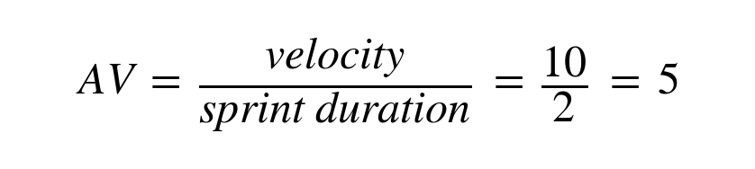

Burndown Chart:
A burn down chart is a graphical representation of work left to do versus time. It is often used in agile software development methodologies such as Scrum. However, burn down charts can be applied to any project containing measurable progress over time.

https://www.visual-paradigm.com/scrum/scrum-burndown-chart/
https://www.atlassian.com/agile/tutorials/burndown-charts

Reference:
https://www.atlassian.com/agile/project-management
https://www.atlassian.com/agile/tutorials/how-to-do-scrum-with-jira-software
https://www.atlassian.com/agile/tutorials/epics
https://www.atlassian.com/agile/tutorials/sprints
https://www.atlassian.com/agile/project-management/estimation
https://www.atlassian.com/agile/tutorials/burndown-charts

